

**Weston Green School**

**Assessment Policy**

This Policy Applies to Weston Green School and Early Years Setting

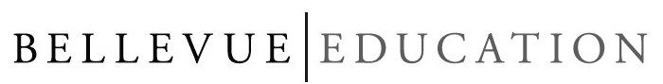

| **Assessment Policy** | p.3 changes to how schools judge attainment  p.5 more scope for schools to explain how they judge attainment |
| --- | --- |

Agreed by (Head and Governance)

Reviewed annually by WGS Assistant Headteacher - Academic - date of last review September 2024

**Introduction and Purpose**

Effective and rigorous assessment is essentially expressed through the following principle:

There is a common language and framework for assessing pupils shared clearly between staff, parents and pupils, so that:

* Assessment drives learning, rather than being a tool for measurement
* Teachers have ownership of data analysis and use this to maximise pupil learning
* Teachers can have reliable conversations with pupils, parents, colleagues about each pupil’s learning
* Parents gain clear understanding of where their child is in their learning and progress they have made
* Pupils know where they are in their learning and where they need to go next
* The school can make key strategic decisions about curriculum design for effective learning

In order for us to gain a full picture of each child’s learning profile, the school uses a number of indicators, looking at Potential **(P)** Attainment **(A)** Progress **(P)** and Attitudes **(A)** (P.A.P.A) and these are gathered consistently through our diagnostic1 formative2 and summative3 assessment processes. This enables teachers to make the most informed and impactful decisions about:

* where each pupil is in their learning,
* where they need to go next in their learning
* what they will need in order to get there
* what the best pathway is for the learning
* how their perceptions about themselves as learners impact on their learning

Data Collection: The purpose of collecting any data about a pupil/cohort in the school is to understand and use

it to make informed and evidence based decisions about next steps and interventions that will lead to the best

outcomes for those pupils and to then compare data sets to ensure these have had the desired impact,

supporting in signposting what further action is needed. At WGS we complete this termly; so that teachers

create actions from their analysis to maximise pupil learning and outcomes for the following term; this is

quality assured internally through staff training and discussions and external quality assurance is provided by our central education committee through governance.

Assessment and GDPR: Individual pupils’ assessment data is part of pupils’ personal information. Care should

be taken with the collation, storage and analysis of data. While it is appropriate to share consolidated

assessment information outside of school any individual data must be anonymised - referenced also in

Curriculum Policy

**Key Terms:**

1Diagnostic assessment: checking of prior knowledge and gaps in order to clearly establish teaching and learning needs and starting points

2Formative assessment: the process of collecting detailed information that enables the teaching and learning to be adaptive to meet the learning needs of the pupils, *while it’s happening*. This is also known as *assessment for learning (AFL)*

3Summative Assessment: commonly summative assessment is conducted at a point in time, through evaluation of learning (using a test or a summative judgement of the formative acquisition of skills); however, wherever possible, the summative assessment should be used FOR learning and provide diagnostic information for moving onto the next steps in learning, not simply a summary OF learning.

**Potential (P)**

***What is potential?*** Aptitude for acquiring and using new skills and knowledge.

It is important to note that research demonstrates a number of factors that can increase a pupil’s learning beyond their ‘measured potential’ and therefore if, for example, a child displays a lower CATs score, this is not a reason to limit the learning pathways or the aspiration of that pupil. The school will always use it as a starting point in conjunction with all other data measures to ensure that all support and challenge is targeted to aspire to exceed potential.

***Why and how do we measure potential?*** to give us an indicator of a pupil’s aptitude for learning and their wider skills to enable our teachers to provide targeted support and challenge for individuals and to make informed decisions about a pupil’s progress.

**In Early Years:** a baseline of each pupil’s knowledge and skills against the Early Years Framework and the Characteristics of Effective Learning as they come into the Early Years can give effective insight into a child’s potential throughout their EYFS experience.

**Y1 & Y2:** end of reception ELGs and attainment offer a measure of predictive indicators into Y1 and Y2 and how they will perform in relation to curriculum demands. It is therefore part of the school’s practice to seek some external moderation of the EYFSP data each year, as well as robust internal moderation.

**Y3 onwards:** standardised CATs (Cognitive Ability Tests) are administered annually to provide information and understanding about pupils’ wider abilities. They are curriculum independent tests and are measured against National Benchmarks. They give a clear indication of learning potential.

***How does it relate to other aspects of P.A.P.A. and how do we use this data?***

Potential measures can create predictors for a pupil’s actual performance in day to day learning and tests; for example, Combination Reports in GL can be used to compare Potential as assessed in CAT4 tests, against Attainment as measured in PTE/PTM tests.

**Attainment (A)**

***What is attainment?***

Attainment is the achievement of skills and knowledge to a level of depth and competency within a set and agreed framework.

***Why and how do we measure attainment?***

Effective formative assessment enables teachers to plan carefully to ensure they maximise the learning opportunity and challenge for each pupil in each lesson and consolidate skills where necessary.

The school measures the attainment of each pupil cumulatively on a day to day and skill by skill basis (this is formative assessment) using carefully designed criteria that support judgement of how pupils are able to independently apply a skill or knowledge (the depth of acquisition), against national curriculum objectives, as set out in the table below:

| Ability | Definition |
| --- | --- |
| Exceeding | Skill, knowledge or understanding is demonstrated and applied **naturally** and in context without any prompting or modelling.  Moderation and triangulation shows that it is applied confidently and consistently, such as:  - outside of lessons and subjects related to this area  - across different contexts (eg - projects/ homework)  - in tasks combining multiple skills (eg - problem solving/ investigation/ independent writing projects)  - Pupil is able to explain it to others |
| Secure | When a skill or objective is modelled/ taught the pupil fulfils all aspects of the criteria within their work, and is able to apply the concepts independently and **consistently** in context within a lesson related to this area. Ready to deepen understanding with further challenge. |
| Developing | Once modelled, although the pupil can employ the skill,   * They are not fully independent: the child needs some adult intervention to initiate or employ the skill, this may be through the form of scaffolding, further modelling, or visual/ verbal prompts * this is **not consistent** * does not perform elements of the criteria e.g. number bonds to 20 makes mistakes when adding two single digit numbers to go across ten |
| Beginning | The skills, concept or body of knowledge has been taught but is **rarely** shown or applied consistently or appropriately, **without direct adult support**; or the child is operating well below the targeted indicator, e.g. number bonds to 20, but the child only knows bonds to 10 |
| Not Achieved | An area that has either not been covered in the curriculum, or in which the child has shown no evidence of the indicator |

These skills are collated and combined over time using a tool such as Pupil Asset, the school’s electronic assessment tracking tool, to create a Point In Time Assessment (PITA), which is a summative judgement (Appendix 1) to demonstrate how a pupil is attaining at that point against the agreed framework and in relation to ARE.

Years 1 - 6

In order to help teachers make effective, reliable and consistent judgements, the school has chosen to use a framework, agreed and developed within the Bellevue schools, which outline clear age-related expectations based on the National Curriculum for:

* English (Reading and Writing, including spelling, grammar and handwriting)
* Maths

The school is mindful of pupils’ assessment and progress across all areas of the curriculum and uses Pupil Asset to both recognise pupils’ achievements and to ensure planning for ambitious learning and development in all areas.

## **Judging Attainment**

In order to make a judgement about a child’s level of attainment, the following cycle would be typical:

* Using the framework and achievement summaries to plan from pupils’ starting points
* Teaching subject content
* Formative assessment of individual skills
* Tracking of individual skills and depth (through the use of Pupil Asset/ MIS tracking)
* Informal and formal summative assessment
* Moderation of work and triangulation of objectives tracked on Pupil Asset/ MIS tracking
* Teacher judgement of pupils’ PiTA colour band
* Use of Pupil Asset exemplifications to assist with judgement*
* Output of PiTA using auto calculate on Pupil Asset to calibrate judgements

**\*Link to Pupil Asset exemplifications for Bellevue schools can be found** [**here**](https://drive.google.com/drive/u/0/folders/0B9hRgASSRVt7dVk0SUhpWk1iMXM)

***How does it relate to other aspects of P.A.P.A. and how do we use this data?***

Measuring attainment also gives clear information between two points in time as to how a pupil has progressed in relation to their potential and previous attainment and will often give some indicators as to their attitudes towards their learning, particularly if they are attaining well above or well below their potential. Additionally, standardised testing such as PTE/PTM and NGRT/NGST can provide both summative and diagnostic information about where a pupil is in their learning and what their next steps will be.

**Progress (P):**

***What is progress?*** Progress is the rate with which a pupil develops the depth of skills and knowledge towards attaining the set curriculum goals in relation to ARE

***Why and how do we measure progress?*** Progress is a good indicator of a pupil’s continued success in relation to their prior performance and whether they are continuing to be successful in school, as well as how they are performing against their potential capability. The school measures progress from both standardised testing and teacher assessments

**Standardised testing to demonstrate progress**: Using comparisons of pupils’ data between their test to test PTE/ PTM/ NGRT/NGSTs can provide indicators of progress by showing an uplift in results against previous data within and across years.

**Formative teacher Assessment, tracked in Pupil Asset to demonstrate progress**:

Broadly: Within the Bellevue PiTA model, attainment is coded by colour as well as language. This can be used to track progress against prior attainment. The progress will be measured between two points by both looking at the colour bands of attainment and through generating a progress report within Pupil Asset based on the rate and depth with which each child acquires skills and knowledge:

Progress Report in Pupil Asset:

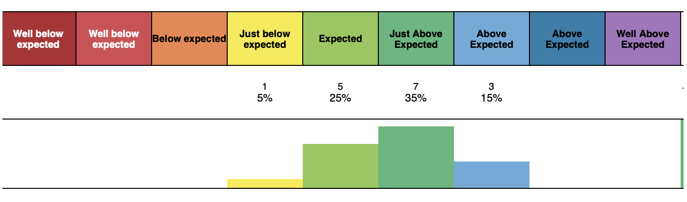

In a detailed way: by being able to look forensically at the specific areas of progress and gaps in understanding and learning using ‘Ghost Rows’ [Appendix 3 - gives an example of how *Ghost Rows* are used by the school to track individual pupil progress in detail]

The school undertakes Pupil Progress Meetings (termly) to ensure that pupils are making at least expected levels of progress and to identify actions for those pupils who may need targeted intervention.

*Meeting Individual Needs*

The responsibility for identifying, assessing and monitoring children with special educational needs or who are gifted and talented, is the responsibility of the class teacher in conjunction with the SENCo. Further detail on this is covered by policies for SEND and Able, Gifted and Talented.

***How does it relate to other aspects of P.A.P.A. and how do we use this data?***

Using this measure alongside attainment and potential prevents high attaining pupils from ‘coasting’ because they ‘look’ like they are ‘doing well’, and equally prevent low attaining pupils from being judged as ‘not doing well’, even if they are making significant progress and closing the ARE gap between themselves and their peers. It will be used to triangulate between the other measures within P.A.P.A.

**Attitudes (A):** a pupil’s response to their learning experience and the way they engage with learning and school.

**Why and how we measure attitudes:**

How pupils feel about themselves as learners and their attitudes to school and their teachers has a known and sometimes profound impact on how they achieve within lessons and overtime at school. It is therefore a critical part of the assessment process to establish pupils’ perceptions of their school and learning experience and to take into account pupils’ views of themselves as learners and how their dispositions and attitudes may tell us more about their performance.

At Weston Green, as well as day to day observable attitudes in lessons and throughout other aspects of the school day to give us qualitative measures of pupils’ attitudes to learning, we also use a standardised survey called PASS (Pupil Attitudes to Self and School) annually to gain a detailed picture of each child’s attitudes from Year 1 - Year 6 and their feelings about their learning and school experience.

***How does it relate to other aspects of P.A.P.A. and how do we use this data?***

Pupil attitudes are like the missing piece of the jigsaw in understanding WHY a pupil may be getting consistent or disparate results across their other areas and why their attainment and progress might not match their potential.

Once our teachers are equipped with this full picture, they are able to conference with individual pupils in order to understand how aspects of their school experience may be affecting their learning and how this can be improved with the right kind of intervention and support.

**Early Years Assessment**

A comprehensive Baseline assessment is completed on entry into either Pre Prep or into Reception at Weston Green. This Baseline is informally assessed by teachers as children are undertaking their usual range of activities. This enables the staff to establish starting points for individual children's learning, track their progress and support the learning of each individual throughout their time in Reception. A similar process is undertaken on entry into our Kindergarten setting whereby the staff identify the key areas of support and challenge necessary for each individual child. In Nursery, we complete the Two Year Check throughout the months leading up to the child's 3rd birthday and this informs where additional support or extension is needed.

On a termly basis, we meet as a staff team and discuss each individual child, with a view to ascertaining how they are progressing through the Early Years Framework, across the seven areas of learning (Physical Development, Communication and Language, Personal, Social and Emotional Development, Literacy, Mathematics, Understanding the World and Expressive Arts and Design). These discussions inform future intervention programmes, challenge opportunities and wider provision across the class or year group. Termly monitoring of phonics and maths acquisition is also undertaken throughout Reception.

At the end of the Early Years Foundation Stage (end of Reception) the EYFS profile is completed for each child to demonstrate if they have met the 17 Early Learning Goals as prescribed by the Framework.

Throughout their time in Early Years, the staff complete observations of the children on an on-going basis. These observations are recorded in our online learning journal, Tapestry, and shared with parents as close to the time of the observation as possible. This provides a regular insight into the learning opportunities being provided for the children whilst at school with the aim to develop the communication not only between school and home but also between families about life at Weston Green.

Summative assessment: is carried out termly and recorded termly using Pupil Asset tracking in the relevant areas of learning appropriate to the age group being assessed. Progress towards Early Learning Goals (ELG) and Good Level of Development (GLD) is also taken into account to ensure pupils’ needs continue to be met appropriately.

The EYFS Profile is completed at the end of Reception for each child to demonstrate whether they have met all ELGs and achieved a GLD. The school will indicate to parents where their child is working beyond the curriculum, although the school recognises that this is not a requirement of or recognised by the statutory EYFS profile. The school applies its EYFS framework & assessment in relation to the Bellevue EYFS Shared Aims and Principles.

**Whole School Assessment Cycle**

The school provides points throughout the year for both internal and external assessment gathering, analysis and reporting. Please see Appendix 2 for details of our assessment calendar.

**Moderation**

Moderation meetings take place termly on a formal basis in the core subjects.

The purpose of these meetings is to:

* ensure consistency both between and across year groups on achievement. This requires all staff to have a thorough understanding of the framework and what constitutes the depth to which individual objectives are learned: whether pupils have developed competency at a Beginning, Developing, Secure or Exceeding depth and how this triangulates within evidenced bodies of work. This process also serves as an evaluation of the opportunities available to pupils that offer development of deeper learning and application to other contexts and subjects.
* ensure that learning is tailored to the ongoing needs of pupils, rather than fulfilling a framework obligation (for example, if all pupils are using paragraphs frequently and accurately without prompting in their writing across other subjects, this would indicate that they are *exceeding* in this area and would not need to have taught lessons on this)
* supports staff in looking at in year and above and below year expectations
* support staff in developing high quality formative feedback
* supports staff in analysing gap analysis for their cohort
* generate professional conversations between class teachers, across year groups and all levels of leadership.
* support staff in developing a thorough understanding of what the different standards of work look like, for example through regular sharing of expectations in planning meetings and the development of portfolios of exemplar work

# **Roles and responsibilities**

Teachers are responsible for:

(i) ensuring that they are familiar with and consistently implement the content of this policy and the standards within the assessment framework

(ii) the day to day learning needs of the children

(iii) monitoring and evaluating the progress of the children they teach and care for

(iv) equipping children to have cogent conversations about where they are in their learning and next steps

(v) reporting clearly and accurately to parents, subject leaders and senior leaders on PAPA

Subject leaders are responsible for:

(i) having the strategic overview of their subject driven by data evidence

(ii) providing the framework of progression for their subject

(iii) ensuring that the monitoring of the cycle and the quality of assessment in their area is carried out in an accurate and timely manner (Appendix 1)

(iv) providing support and training to teachers to enable them to teach and assess their impact and pupils individual needs effectively

(v) leading the development and reliability of assessment within their subject through regular and effective moderation

Senior leaders are responsible for ensuring that there is:

(i)  a consistent understanding of the framework and implementation of the assessment strategy

(ii) quality assurance around the processes surrounding learning and assessment across the school

(ii) time to effectively evaluate and refine assessment processes so that they remain fit for purpose

(iii) a clear cycle of CPD to ensure that staff are sufficiently equipped

(iv) time for leaders to monitor their subject, train staff and evaluate impact

(vi) time for teachers to reflect on formative assessment, analyse summative assessments and calibrate judgements with colleagues/ moderate

(vii) continual raising of standards through the use of data analysis to target groups of and individual pupils and that there is a culture of individualised approach to learning

(vii) visibility for parents on their child’s learning and that this is communicated clearly

**Reporting to parents:**

At WGS school we believe in ensuring our parents are part of the learning partnership and our reporting system enables them to have visibility of their children’s learning and progress through termly academic, written reports, pupil conferencing sessions and parent consultation meetings.

**Appendices**

Appendix 1: [Bellevue] Point In Time Assessment (PITA) Model

The school uses a Point In Time Assessment model, which ensures that at any given reporting point, it is clear to see whether a pupil is attaining at, above or below the expected standard for Weston Green School and how they are performing against national benchmarks.

**Summative Assessment Language and Descriptors**

| Colour map descriptors for summative | **%**  **weighted curriculum** | **Benchmark Assessment Descriptors** | **Scaled scores**  **(KS2 NC)** | **GL (SAS)** | **GL**  **Bands** | **Reporting to parents** |
| --- | --- | --- | --- | --- | --- | --- |
| Significantly below ARE | >5% | -Is largely or wholly unable to access the curriculum, despite intense personalised support and scaffolding,  -Will be following a different curriculum to the rest of the class.  -Likely to be working more than 1 year behind ARE and have an individualised support plan. | <85 | >73 | Very low | Working Well below National Standard |
| Well below  ARE | 5-14% | -Is working below age related expectations and is only able to access year group curriculum with heavily personalised support and scaffolding,  -May be undertaking different tasks to the rest of the year group.  -Working approximately 1 year behind ARE | 85-89 | 74-81 | Below Average |
| Below  ARE | **15-27%** | Is able to access the year group curriculum with personalised support and scaffolding. Has significant gaps in learning. May be doing some different tasks to the rest of the class and may be receiving, or needing some intervention to secure core learning. Working 2 terms behind ARE. | 90-94 | 82-88 | Working  Below National Standard |
| Just below  ARE | **28-45%** | -Is able to access the correct curriculum but sometimes need some scaffolding or support.  -Has some gaps in their learning but is on track in a number of expected areas.  -Sometimes struggles to acquire and embed concepts  -Rarely applies learning of year group objectives independently  -Likely to be working approximately 1 term behind ARE. | 95-99 | 89-96 | Average |
| At ARE | **46-60%** | -Is secure in many, but not all, of ARE and is showing sound understanding of over half of the objectives taught.  -Is more often than not successful at learning new concepts and is starting to apply their skills independently, but not consistently. -Needs minimal scaffolding, but occasional prompts.  -May have some smaller gaps in learning which need closing in order to become secure. | 100-104 | 97-103 | Working within expected (National) standard |
| Just above ARE | **61-90%** | -Is meeting national ARE.  -Is usually a successful learner, at that year group level, showing good understanding of and can apply over 80% of the curriculum objectives taught.  -Usually able to learn new skills and use them accurately and independently, though they may make occasional errors in applying their learning in other contexts. | 105-109 | 104-111 |
| Securely Above ARE | 91%+ | -Is starting to exceed national expectations and is always successful in understanding the key learning/ objective taught, with few errors when applying acquired skills or learning independently to a range of contexts, often explaining or justifying ideas.  -Likely to be working at least 1-2 terms ahead of ARE | 110-114 | 112-118 | Above average | Working above expected standard (or at school’s standard ) |
| Well Above ARE | **31-60%**  **yr grp above** | Is exceeding year group ARE.  -Is always successful in understanding the key learning objective. -Can consistently apply their skills independently in a range of contexts, with minimal error and can explain and justify their ideas.  -Often able to see links between concepts and how these work as part of a bigger picture.  -Likely to be working at least 2-3 terms ahead of ARE | 115-118 | 119-126 |
| Significantly above ARE | **61%+ yr grp above** | -As above, but is more often than not working significantly beyond the year group objectives and demonstrates significant skills and knowledge beyond the curriculum.  -Can consistently extend thinking to link several ideas, make generalisations and consider and use these in new and different ways. -Can synthesise and evaluate their own and others' ideas effectively.  -Likely to be working at least 4 terms ahead of ARE | 119-120 | 127-141 | Very High | Working significantly above |

If a member of staff is seeking to summatively assess a pupil as attaining a colour band beyond the year range (Dark Blue/Purple) this would only occur where the pupil is consistently demonstrating ‘exceeding’ in formative assessment skills statements and this has been triangulated against evidence in, for example: pupil progress meetings and moderation meetings as well as in day to day observations by the teacher. Auto calculate on Pupil Asset would indicate whether the pupil had achieved enough skills/objectives to be judged in each of the colour bands and needs to be used to calibrate judgements. Additionally, Pupil Asset exemplifications are to be used to assist this moderation in all aspects of Maths and English. These can be found [**here**](https://drive.google.com/drive/u/0/folders/0B9hRgASSRVt7dVk0SUhpWk1iMXM)

Appendix 2: Weston Green Assessment and Reporting Cycle

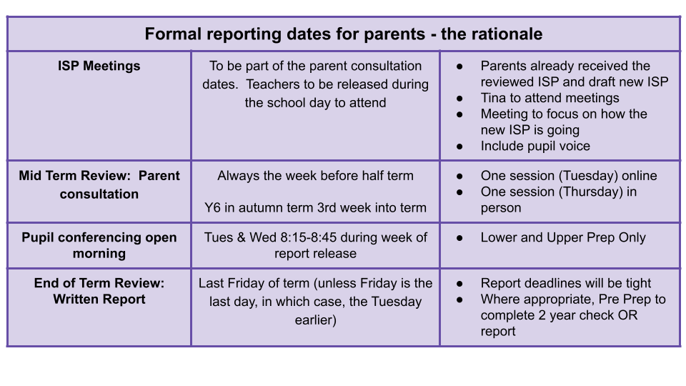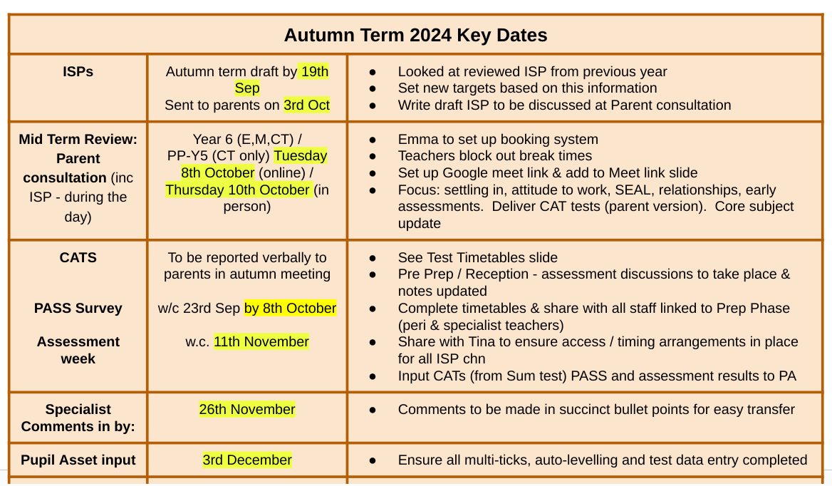

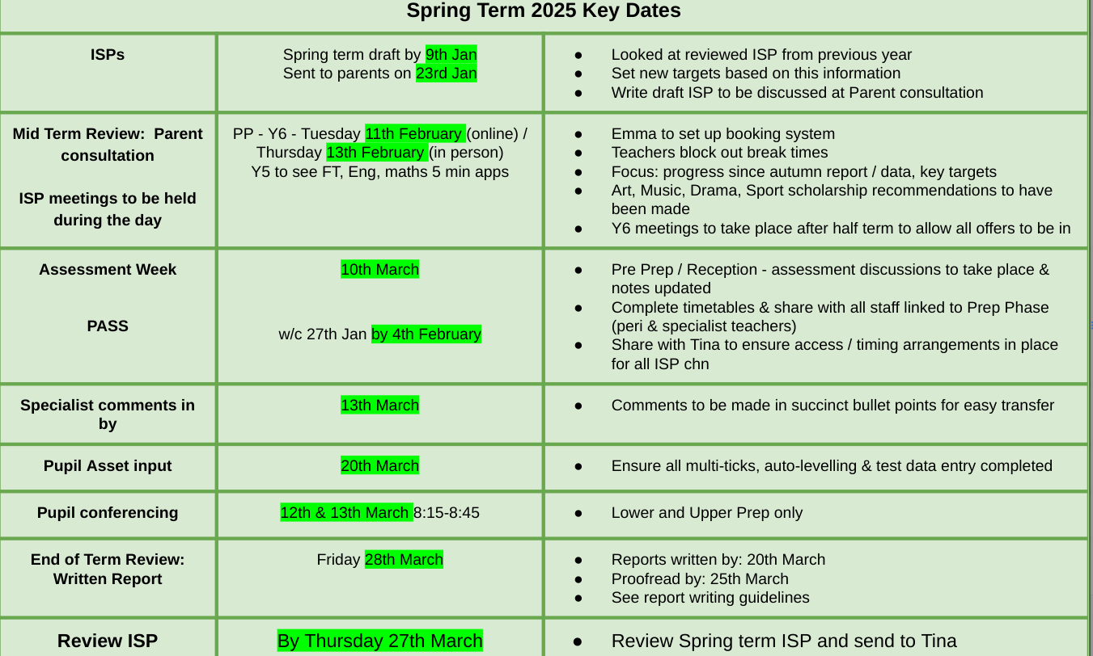

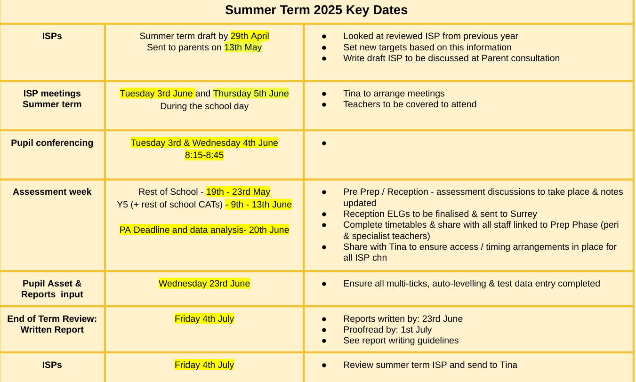

Appendix 3: Examples of Using Ghost Rows (in Pupil Asset) to show detailed progress breakdown

by tracking the pupils on a skill by skill level and comparing these each half term, eg: by using ‘ghost rows’ in Pupil Asset reading from bottom to top the teacher can track progress forensically and identify specific strengths and areas for development

